Start jenkins by below command

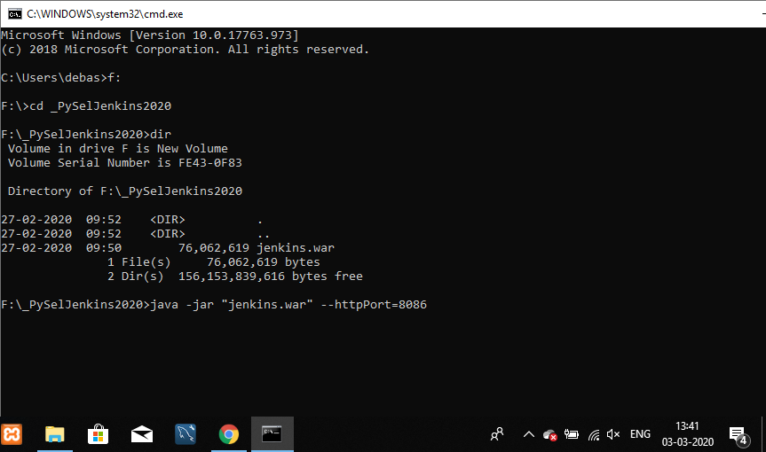

Microsoft Windows [Version 10.0.17763.973]

(c) 2018 Microsoft Corporation. All rights reserved.

C:\Users\debas>f:

F:\>cd _PySelJenkins2020

F:\_PySelJenkins2020>dir

Volume in drive F is New Volume

Volume Serial Number is FE43-0F83

Directory of F:\_PySelJenkins2020

27-02-2020 09:52 <DIR> .

27-02-2020 09:52 <DIR> ..

27-02-2020 09:50 76,062,619 jenkins.war

1 File(s) 76,062,619 bytes

2 Dir(s) 156,153,839,616 bytes free

F:\_PySelJenkins2020>java -jar "jenkins.war" --httpPort=8086

Running from: F:\_PySelJenkins2020\jenkins.war

webroot: $user.home/.jenkins

Mar 03, 2020 1:43:53 PM org.eclipse.jetty.util.log.Log initialized

INFO: Logging initialized @7690ms to org.eclipse.jetty.util.log.JavaUtilLog

Mar 03, 2020 1:43:54 PM winstone.Logger logInternal

INFO: Beginning extraction from war file

[33mMar 03, 2020 1:44:10 PM org.eclipse.jetty.server.handler.ContextHandler setContextPath

WARNING: Empty contextPath

[0mMar 03, 2020 1:44:10 PM org.eclipse.jetty.server.Server doStart

INFO: jetty-9.4.z-SNAPSHOT; built: 2018-08-30T13:59:14.071Z; git: 27208684755d94a92186989f695db2d7b21ebc51; jvm 1.8.0_211-b12

Mar 03, 2020 1:44:15 PM org.eclipse.jetty.webapp.StandardDescriptorProcessor visitServlet

INFO: NO JSP Support for /, did not find org.eclipse.jetty.jsp.JettyJspServlet

Mar 03, 2020 1:44:15 PM org.eclipse.jetty.server.session.DefaultSessionIdManager doStart

INFO: DefaultSessionIdManager workerName=node0

Mar 03, 2020 1:44:15 PM org.eclipse.jetty.server.session.DefaultSessionIdManager doStart

INFO: No SessionScavenger set, using defaults

Mar 03, 2020 1:44:15 PM org.eclipse.jetty.server.session.HouseKeeper startScavenging

INFO: node0 Scavenging every 660000ms

Jenkins home directory: C:\Users\debas\.jenkins found at: $user.home/.jenkins

Mar 03, 2020 1:44:21 PM org.eclipse.jetty.server.handler.ContextHandler doStart

INFO: Started w.@476aac9{Jenkins v2.162,/,file:///C:/Users/debas/.jenkins/war/,AVAILABLE}{C:\Users\debas\.jenkins\war}

Mar 03, 2020 1:44:28 PM jenkins.InitReactorRunner$1 onAttained

INFO: Started initialization

Mar 03, 2020 1:44:28 PM jenkins.InitReactorRunner$1 onAttained

INFO: Listed all plugins

Mar 03, 2020 1:44:38 PM jenkins.InitReactorRunner$1 onAttained

INFO: Prepared all plugins

Mar 03, 2020 1:44:38 PM jenkins.InitReactorRunner$1 onAttained

INFO: Started all plugins

Mar 03, 2020 1:44:38 PM jenkins.InitReactorRunner$1 onAttained

INFO: Augmented all extensions

Mar 03, 2020 1:44:39 PM org.eclipse.jetty.server.AbstractConnector doStart

INFO: Started ServerConnector@76249baa{HTTP/1.1,[http/1.1]}{0.0.0.0:8086}

Mar 03, 2020 1:44:39 PM org.eclipse.jetty.server.Server doStart

INFO: Started @53786ms

Mar 03, 2020 1:44:39 PM winstone.Logger logInternal

INFO: Winstone Servlet Engine v4.0 running: controlPort=disabled

Mar 03, 2020 1:44:46 PM jenkins.InitReactorRunner$1 onAttained

INFO: Loaded all jobs

Mar 03, 2020 1:44:46 PM hudson.model.AsyncPeriodicWork$1 run

INFO: Started Download metadata

Mar 03, 2020 1:44:47 PM hudson.util.Retrier start

INFO: Attempt #1 to do the action check updates server

Mar 03, 2020 1:44:52 PM org.springframework.context.support.AbstractApplicationContext prepareRefresh

INFO: Refreshing org.springframework.web.context.support.StaticWebApplicationContext@3a02e92d: display name [Root WebApplicationContext]; startup date [Tue Mar 03 13:44:52 IST 2020]; root of context hierarchy

Mar 03, 2020 1:44:52 PM org.springframework.context.support.AbstractApplicationContext obtainFreshBeanFactory

INFO: Bean factory for application context [org.springframework.web.context.support.StaticWebApplicationContext@3a02e92d]: org.springframework.beans.factory.support.DefaultListableBeanFactory@32ff50b8

Mar 03, 2020 1:44:52 PM org.springframework.beans.factory.support.DefaultListableBeanFactory preInstantiateSingletons

INFO: Pre-instantiating singletons in org.springframework.beans.factory.support.DefaultListableBeanFactory@32ff50b8: defining beans [authenticationManager]; root of factory hierarchy

Mar 03, 2020 1:44:53 PM org.springframework.context.support.AbstractApplicationContext prepareRefresh

INFO: Refreshing org.springframework.web.context.support.StaticWebApplicationContext@4263ba64: display name [Root WebApplicationContext]; startup date [Tue Mar 03 13:44:53 IST 2020]; root of context hierarchy

Mar 03, 2020 1:44:53 PM org.springframework.context.support.AbstractApplicationContext obtainFreshBeanFactory

INFO: Bean factory for application context [org.springframework.web.context.support.StaticWebApplicationContext@4263ba64]: org.springframework.beans.factory.support.DefaultListableBeanFactory@6c1bf2d

Mar 03, 2020 1:44:53 PM org.springframework.beans.factory.support.DefaultListableBeanFactory preInstantiateSingletons

INFO: Pre-instantiating singletons in org.springframework.beans.factory.support.DefaultListableBeanFactory@6c1bf2d: defining beans [filter,legacy]; root of factory hierarchy

Mar 03, 2020 1:44:53 PM jenkins.install.SetupWizard init

INFO:

*************************************************************

*************************************************************

*************************************************************

Jenkins initial setup is required. An admin user has been created and a password generated.

Please use the following password to proceed to installation:

5e1fbe8c09734a74ba3403dd7233be90

This may also be found at: C:\Users\debas\.jenkins\secrets\initialAdminPassword

*************************************************************

*************************************************************

*************************************************************

Mar 03, 2020 1:45:15 PM hudson.model.UpdateSite updateData

INFO: Obtained the latest update center data file for UpdateSource default

Mar 03, 2020 1:45:21 PM hudson.model.UpdateSite updateData

INFO: Obtained the latest update center data file for UpdateSource default

Mar 03, 2020 1:45:31 PM jenkins.InitReactorRunner$1 onAttained

INFO: Completed initialization

Mar 03, 2020 1:45:32 PM hudson.WebAppMain$3 run

INFO: Jenkins is fully up and running

Mar 03, 2020 1:45:33 PM hudson.model.DownloadService$Downloadable load

INFO: Obtained the updated data file for hudson.tasks.Maven.MavenInstaller

Mar 03, 2020 1:45:34 PM hudson.util.Retrier start

INFO: Performed the action check updates server successfully at the attempt #1

Mar 03, 2020 1:45:34 PM hudson.model.AsyncPeriodicWork$1 run

INFO: Finished Download metadata. 47,376 ms

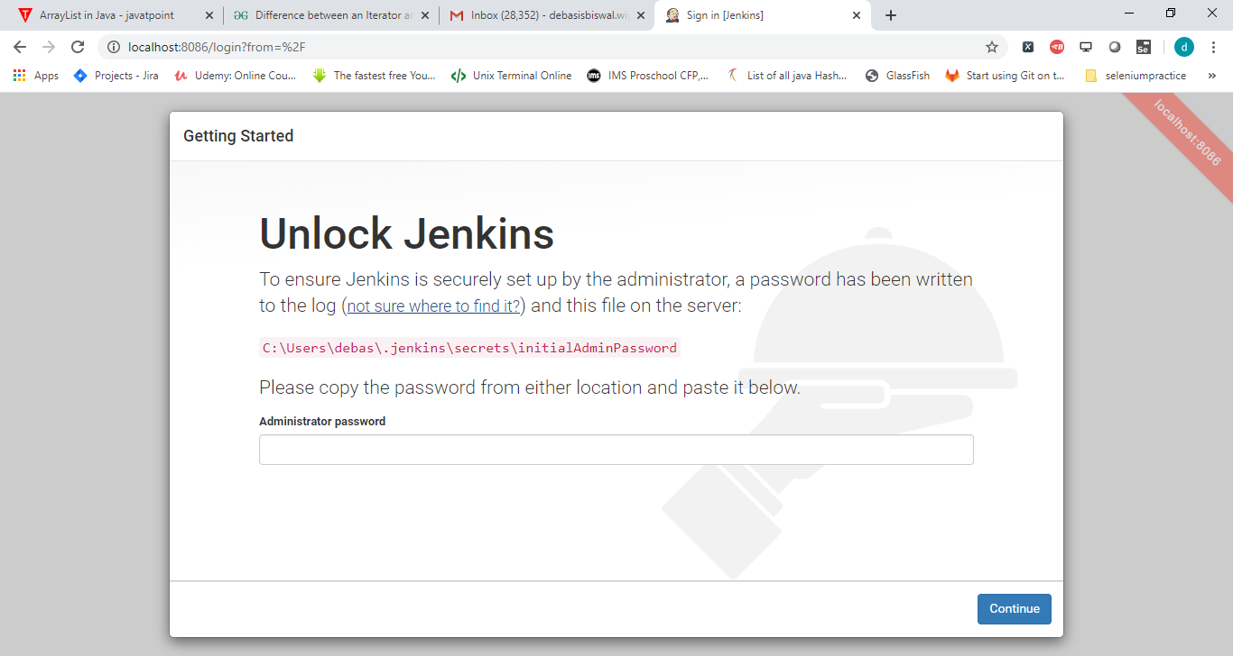

Initialid pwd

**5e1fbe8c09734a74ba3403dd7233be90**

**Click on suggested plugin**

